PROJECT MANAGEMENT
  - FEASIBILITY STUDY:
    - Technical Feasibility:
In this project we use some web technology like front end: html,css,js and backend: php ,data-base: mysql and also use other toll like wampserver and code-editor: notepad++ ,vscode. The technical feasibility of developing an eyewear website appears strong, given the available technologies and resources. With careful planning and execution, the project can meet the needs of the target audience effectively.

    - Operational Feasibility:
Creating a website for an eyewear brand means checking if it’s possible and manageable to keep running in the long term. This includes looking at whether you have the right resources (like people, technology, and money), making sure the technology works well and is easy to use, and seeing if the website can fit into the brand’s current operations without causing any problems.

    - Economical Feasibility:
An eyewear brand website can save money in many ways. First, it costs much less to run a website than to open a physical store. You don’t need to pay for renting or buying a store, keeping up a showroom, or hiring many staff members. A website also helps you reach more people without being limited by location, which can grow your customer base and sales.
If you're developing the website for online and h osting purpose, the cost might include software tools (if needed) and developer time. If you're outsourcing, consider freelance developer costs or agency fees are included.

  - PROJECT PLANNING:
2.2.1 Project Development Approach & Justification:

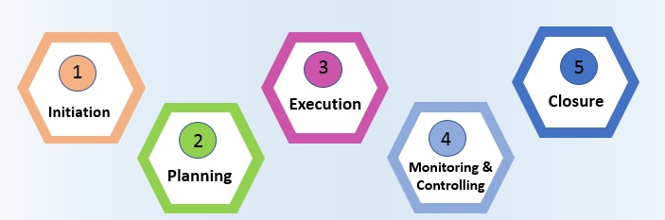
How use this model for developing this project
- In the initiation phase, you will define the project. You will sort out the project goals, scope, and resources of the project and what roles are needed on the team. Clarifying what stakeholders expect out of the project, and what exactly the project is aiming to achieve (and why) will give the project and team clear direction.
- In the planning phase, you will determine the steps to actually achieve the project goals—the “how” of completing a project. You will establish budgets, timelines, milestones, source materials, and necessary documents. This step also involves calculating and predicting risk, establishing change processes in place, and outlining communication protocols. If the initiation phase is assembling your troops, the planning phase is deciding what to do with them.
- Executing a project means putting your plan into action and keeping the team on track. Generally, this means tracking and measuring progress, managing quality, mitigating risk, managing the budget, and using data to inform your decisions. Specific steps might include:
  - Using tools like DFD and E-R or burndown charts to track progress on tasks
  - Responding to risks when they manifest
  - Recording costs
  - Keeping team members motivated and on task
  - Keeping stakeholders informed of progress
  - Incorporating changes via change requests
- In the closing phase of the project management lifecycle, you will conclude project activities, turn the finished product or service over to its new owners and assess the things that went well and did not go so well. It will also be a time to celebrate your hard work. Steps in the closing phase can include:
  - Conducting retrospectives and take notes of changes you can implement in the future.
  - Communicating to stakeholders at the end of the project and providing an impact report
  - Communicating with the new owners of a project.
  - Creating a project closeout report
  - Celebrating the end of the project and your successes
  - PROJECT SCHEDULING:
Scheduling in project management is the listing of activities, deliverables, and milestones within a project. A schedule usually includes a planned start and finish date, duration, and resources assigned to each activity. Effective project scheduling is a critical component of successful time management, especially for professional service businesses.

In this guide, we will explore the concept of scheduling in project management, its importance, and how it is done. We will also look into the different scheduling techniques, tools, and best practices that project managers can leverage to keep their projects on track and deliver successful outcomes.
If you are looking for a tool that will allow you to have full control over the scheduling processes for your projects, Wrike has the right solution for you. You can start today and unlock the full power of project management.
Resources required for Development of Project:
- Human effort
- Sufficient disk space on server
- Specialized hardware
- Software technology
- Travel allowance required by project staff, etc.
Advantages of Project Scheduling:
- It simply ensures that everyone remains on same page as far as tasks get completed, dependencies, and deadlines.
- It helps in identifying issues early and concerns such as lack or unavailability of resources.
- It also helps to identify relationships and to monitor process.
- It provides effective budget management and risk mitigation.

